Coral Glades High School
Music Association

Student and Family
Information Packet

-An Overview of the Music Program-

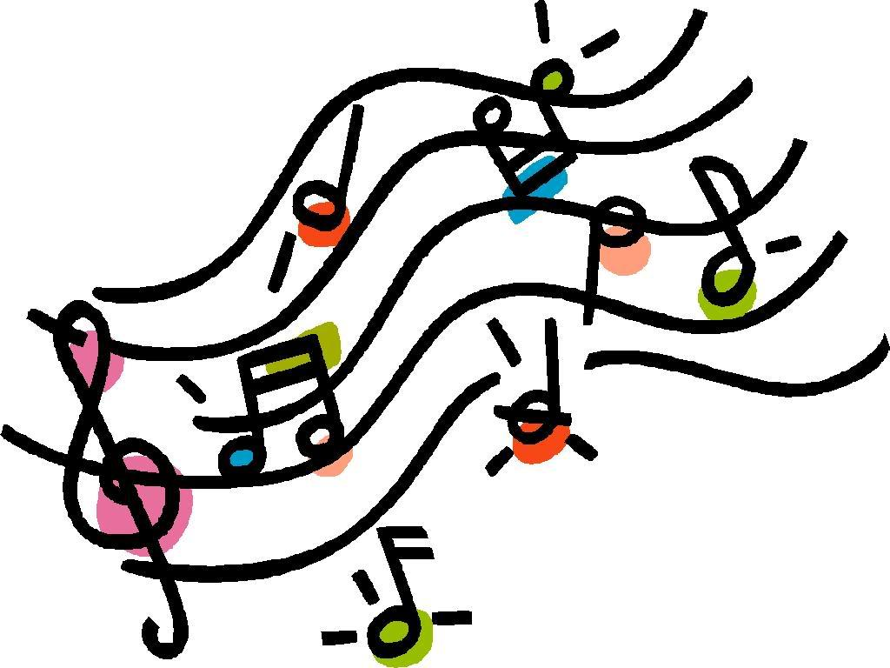

Welcome to the Coral Glades High School Music Program. You have made the decision to be part of an award-winning and growing program that promotes excellence in all areas. The following information has been compiled to answer the frequently asked questions of new members but is also helpful to returning students to the program.

Registration Procedures

All incoming freshmen should select “Band 1,” “Orchestra 1,” and/or “Eurhythmics 1” (Guard) on their Coral Glades course card. The Music Director will audition students for placement in level-appropriate classes either in the late spring or early fall.

Once you have registered for the program, please complete the Permission Form for Medical Treatment provided to you or available on our website (cghsmusic.org). This form provides the Music Association with all pertinent contact and medical information for use throughout the school year. We communicate with parents and students regularly via text and email as well as our Facebook page (CGHS Music).

Participation in Band is a Full Year Commitment

The Coral Glades Music Program follows a school year-long performing curriculum – we perform as a marching and concert band throughout the school year. The marching band consists of all winds, percussion, and guard students. Marching band includes sessions in May, a week-long camp in June, a week-long camp in August, practices two or three times a week in fall, football games, competitions, and the Coral Springs Holiday Parade in December. Concert band begins in the classroom in the fall and includes a winter concert, practices in the spring, and a spring concert.

At the end of the marching band season, color guard transitions into winter guard. Coral Glades Guard Ensemble is a member of the South Florida Winter Guard Association (SFWGA.com), which provides a venue for students to continue the marching band auxiliary and drill team experience into the winter and spring months. Winter guard practices begin in December and competitions run from January through May. The percussion students also have the option of choosing to join an indoor percussion ensemble outside of CGHS.

Based on the year-long commitment required from our music program students, it is not uncommon for a conflict in extracurricular activities to occur with our music program schedule. Once a student realizes or anticipates a conflict, the student should bring it to the attention of the music director, so an appropriate solution can be determined.

I Want to be in Band and Orchestra

Students who choose to participate in both band and orchestra will be scheduled for the Band 1 and Orchestra 1 classes. They may audition for consideration towards a higher-level class. Based upon the curriculum, the student must participate in all marching band requirements for the marching season. The student will also participate in all performances for orchestra, as typically there are no conflicts between orchestra and band during the marching season.

Band and Orchestra Camps - All Students

The Coral Glades Music Program runs several camps prior to the start of school in August. The camp in June is designed to introduce new students to the program and to prepare them for integration into the rest of the band. The students will learn marching drill, practice the music, exercise to build endurance, and work with the music program leaders and clinicians to prepare them for the August band camp. At the completion of the camp, they should be fully aware of what is expected of them for the fall marching season. They will also have met and worked with band leadership and know their way around the music room and the school.

In August, specialty band camp sessions are held - all of which are mandatory. Percussion camp, guard camp, and full marching band camp are held prior to the start of school. The dates will be provided in advance and will be posted on the website.

Living in Florida, our students will perform in uniform during marching season in hot and humid weather. Attending band camp is part of their conditioning for the anticipated demands of the season. We encourage our students to not only practice their instruments during the summer, but to also exercise outside so as to be acclimated when the school year begins.

What is the Camp Day Like?

Your student should arrive at least 15 minutes before the scheduled practice time. This allows for instrument setup, preparation, and movement to the practice areas. The reverse takes place at the end of the practice. Therefore, please be advised that your student may be ready for pickup 15 to 30 minutes after the end of practice. In addition, as directed by leaders and/or clinicians, students may need to prepare for the next practice. We encourage our students to take responsibility for the instruments, equipment, and program. We are a team!

Marching band takes place on a field; therefore, most practices are outdoors. (In case of steady rain or lightning, practice will immediately be moved indoors.) Students should drink plenty of water the night before a practice to ensure they are well hydrated. They should not consume dairy products the morning of a practice. Students should bring a thermal jug (2 quarts or larger) of cold water to practice for the frequent water breaks. Students may refill the jug at lunchtime.

Snacks/Lunch

If the camp session is a full day, the student should pack a substantial bag lunch and beverage. Students will not leave the school property for meals during camp. If the camp goes beyond the dinner hour, they may purchase the optional meal plan or bring a substantial dinner and beverage as well. The students work hard, and they may require more food during this period so plan their food supply accordingly.

Clothing - Sunscreen – Insect Repellent

All students must wear plain or CGHSMA white or light gray t-shirts for practices. Practice and performance shirts will be provided. Tank tops, cut shirts, and sports bras are not permitted. They must wear navy blue or black shorts. Students must wear socks and sneakers for practices and Dinkles for performances. (Dinkles are available locally at All County Music.) Guard will require shoes appropriate to the theme of the show.

The use of sunglasses and hats are strongly encouraged. Students should pack sunscreen and apply it several times during the day. Because the band room backs up to the Everglades, mosquitos and gnats are common. We strongly encourage the use of insect repellent.

Students should also be considerate of others by applying spray sunscreen or insect repellent outdoors.

What if my Student has a Reaction to the Heat?

Occasionally, the heat gets the better of a student and they may feel faint or nauseous. The student should immediately report any illness to a leader, clinician, or staff member. If your student has a chronic health condition, please document it on the Permission Form for Medical Treatment and ensure that your child comes prepared with required medication or equipment to every practice and performance. Depending on the context, students, staff members, or association officers may carry the medication or equipment during practices or performances.

Attendance

Attendance is mandatory for marching band/percussion/guard camps.

Attendance is vitally important for students to collectively achieve the planned progression and effectively contribute to the entire ensemble. The ensemble functions as a single unit; one absence diminishes the result obtained by all other ensemble members. If you are a new student with preexisting vacation plans that may create a conflict, we encourage you to discuss with Mr. Sanchez, the band director, immediately (alexander.sanchez@browardschools.com). All absences must be reported directly to Mr. Sanchez.

What are the Costs and Fees for the Programs?

The Broward County School Board provides very little support for the music program. Fees are necessary to cover the cost of band camps, practices, clinicians, music, flags, props, entry fees, uniforms, instrument rental/maintenance, and transportation. A budget is developed each spring based on the estimated operating expenses for the upcoming year. The total budgeted amount is divided by the number of participating students to determine the cost per student. Because this amount may be prohibitive for many students, the Coral Glades High School Music Association provides fundraising opportunities to keep fees and out-of-pocket expenses at a manageable level.

Fees and payment schedules for each ensemble are shown for the 2022-2023 year. Marching band fees do not include the cost of the state competition or recreational field trips. Color Guard fees do not include winter guard. Fees do not include consumable items such as required shoes, socks, gloves, etc. Students who face difficult financial situations should speak directly with the music director or the president/treasurer of the Music Association.

Payment Schedule 2022-2023
Due Date | Orchestra | Concert Band Only | Marching Band | Color Guard
September 28, 2022 |  |  | $200.00 | $200.00
October 19, 2022 |  |  | $150.00 | $150.00
November 16, 2022 | $50 | $50 | $150.00 | $150.00
Total | $50.00 | $50.00 | $500.00 | $500.00

Are there Other Programs and Fees?

Chamber orchestra is a program offered outside of the classroom for students who choose to audition. The group is directed by upperclassmen in conjunction with the orchestra clinician and music director. Practices and occasional performances are outside of the regular class schedule. There are no fees associated with this program.

Full orchestra is an ensemble during the winter season. As a part of the performing curriculum, it is expected that students in the upper-level strings class participate in this program. Students from concert band may audition to play with full orchestra. Practices and occasional performances are outside of the regular class schedule There are no fees associated with this program.

How do I Pay Fees?

All fees, trip costs, and fundraising money should be paid by

- Check/money order/cash payable to CGHSMA and deposited in the lockbox in the music room. Please place in a sealed envelope with a note indicating the student name and fee/event the payment is to be applied.

- Online payment via our website (cghsmusic.org). Please include a note indicating the student name and fee/event the payment is to be applied.

Fundraising

The Coral Glades High School Music Association (CGHSMA) provides fundraising opportunities to allow each family raise the necessary funds. Many students raise the entire cost of the program through these fundraisers. This is the easiest way to offset the costs associated with being a music program member. Money raised through fundraising efforts may be applied towards fees and expenses. Families should check text messages, email, Facebook, and/or the website in order to stay informed of fundraising opportunities. Suggestions for new fundraising programs should be directed to the Vice President, Fundraising.

Uniforms

Students are measured and issued uniforms at the start of each program. Marching band measurements are usually completed during the band camp in August. Uniforms are stored in the Uniform Room and issued to students prior to each performance. If needed, uniform exchanges are done with the Uniform Coordinator. Following performances, students are expected to take uniforms home to be washed. At the end of the season, uniforms are collected for dry cleaning and repair. Students are asked to be timely when returning uniforms.

Concert dress uniforms are issued to the students for use during concert season. Students are responsible for washing and storing the uniforms at home and bringing it to each performance.

Failure to return all uniforms in their entirety will result in a school obligation.

What does Color Guard Wear?

Color guard wears a uniform designed to enhance the theme of the marching show. Members are sized during guard camp. Costumes are custom-made and takes several weeks to receive. The cost of this costume is included in the guard fees.

Are there other Purchases Required and not Covered in the Fees?

Marching Band: Band members are required to purchase black Dinkles marching shoes for performances and competitions. These are available online at www.dinkles.com or at All County Music Store. The cost is about $30. Students will also be required to purchase and wear black knee socks and marching gloves (supplied by the Music Association). The cost is about $9.

Students will be issued a practice t-shirt and a show t-shirt. The cost is included in the fees.

For camp, students will need to purchase a spiral-bound dot matrix 3”x5” book of index cards at an office supply store. It should be attached to a lanyard for use to mark drill during practice.

Instrument maintenance and supplies are not covered in the marching band fees.

Guard: Additional costs may include:

- Shoes for both marching band and winter guard
- If part of the weapons line, a rifle and/or saber.
- Undergarments for both seasons
- Show make-up for both seasons
- Black and white electrical tape
- Two pairs of gloves
- Duffle bag to carry their possessions
- Flag bag to carry their flags
- Team warm-up suit

Orchestra: Advanced-level orchestra students typically wear their dress concert uniforms issued by the school. Tuxedos may be issued with black dress shoes. Females must purchase black close-toed shoes (flat or moderate heels). Lower-level and chamber orchestra students must wear black pants and black dress shirts or black dresses with black shoes for performances. These items are not provided by the school.

Instrument Rental: Where available, the program will rent an instrument to a student. The student and parent must sign a rental agreement contract and pay the required fee. Summer rental fee is $10.00 cash and covers rental from June-August. School year rental is $20.00 CASH and covers the school year. A copy of the signed contract acts as your receipt.

Dinner Meal Plans during Band Camp and Football Season: Due to the long days, an optional dinner meal plan will be available for camp and football games. Meals include an entrée, side, drink, and dessert and cost about $8 per meal. Alternatively, students may bring their own dinner.

Will the Marching Band Compete?

The marching band usually competes in regional band competitions as well as the mandatory Music Performance Assessment during the season. Costs for participation in these competitions are included in the standard fees. It is essential that students be present for all competitions and assessments. Competition dates and times are provided in advance via flyers, text, email, Facebook, and the website. Participation in a competition is an all day and evening commitment for the students and staff.

Who/What are the FBA and MPA Assessments?

Coral Glades Music Program follows a performing curriculum. Each ensemble is assessed by third party organizations, recognized for their support of the creative arts and their pursuit of best practices. The primary organization in Florida is the Florida Bandmasters Association (FBA). FBA Music Performance Assessments (MPA) are the accepted standard of evaluation for high school bands. We subscribe to their standards of excellence.

The purpose of the assessment is as follows:

- To provide opportunities for students and directors to perform in an environment which provides critical evaluation of its performance by experts in band performance,
- To provide the opportunity for students and directors to perform for their peers in a formal concert setting,
- To provide a performance opportunity which will serve as a motivational goal for students and directors,
- To provide an opportunity for students and directors to hear performances of their peers and learn from hearing those performances, and
- To provide a goal which is so compelling that the preparation for attaining that goal becomes the vehicle for continued growth and to demonstrate students' abilities to apply musical fundamentals and concepts in an ensemble performance setting.

The marching band MPA is in the fall; the concert band MPA is in the spring. Assessments are done on a district and statewide basis. It is essential that students be present for assessments. Families are encouraged to attend assessment performances.

Do Band and Orchestra Classes Prevent me from Taking other Electives?

Students may select other electives while participating in one or more music classes. For the required Health and Personal Fitness credit, students may take the course online via Florida Virtual School. Please speak with a guidance counselor first.

Contact Information:

Band Director: Alexander Sanchez
alexander.sanchez@browardschools.com
754-322-1302

Website: www.cghsmusic.org

Facebook: CGHS Music

